Name: __________________________

Angles and Angle Measure

Angles in the Standard Position:
Definition:
Standard Position: has its vertex at the ___________. Starts on the positive x-axis (_________ arm). Rotates to a _________ arm.
Rotation:
Counterclockwise rotation → ________ angle
Clockwise rotation → ___________ angle
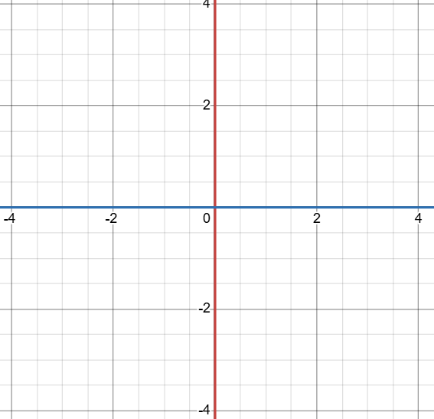
Quadrants:

Quadrant I: ______ $<θ<$ _______.
Quadrant II: ______ $<θ<$ _______.
Quadrant III: ______ $<θ<$ _______.
Quadrant IV: ______ $<θ<$ _______.

Example 1:
Sketch the following angle $150°$.

Ways to Measure Rotation:
Definitions:
Degrees: In ____ full Rotation there is _____ Degrees.
Radians: It measures angles using _____ lengths and _____. One radian is angle formed when the ____ length equals ______.
Relationship:
$π\text{radians}=\text{_______}°$

Example 2:
What angle (in Radians) represents quarter a circle?

Converting between Degrees and Radians

Reference Angles
A reference angle is the __________ angle formed between the __________ arm of an angle in standard position and the __________-axis.

Common Reference angles:

- $45°=\text{___}π$
- $90°=\text{___}π$
- $180°=\text{___}π$
- $360°=\text{___}π$

Example 3: Degree to Radians
Convert $280°$ into radians.

Example 4: Radians to Degrees
Convert $\frac{7π}{4}$ to degrees.

Coterminal Angles:

Identify Coterminal Angles:

Definition:
Coterminal Angles are angles that share the same __________ arm

Example 5:
Determine one positive and one negative Angle measurement for $60°$.

General form for Coterminal angles:

Forms:
The general for has 2 forms: one for_______________ and one for _______________.

- $θ±\text{__________}n$

- $θ±\text{_________}n$

Variables:

- $θ=\text{___________________________}$

- $n=\text{___________________________}$

- $±\text{ is for ________________________}$

- $\text{_________ or ________ is for the _____________________.}$

Example 6:
- Express the angles coterminal with $165°$ in general form. Identify the angles coterminal with $165°$ that satisfies the domain $-720°≤θ≤720°$.

$$n$$
$$165°+360°n$$
$$165°-360°n$$

- Express the angles coterminal with $\frac{2π}{3}$ in general form. Identify the angles coterminal with $\frac{2π}{3}$ that satisfies the domain $-4π≤θ≤4π$.

$$n$$
$$\frac{2π}{3}+2πn$$
$$\frac{2π}{3}-2πn$$

Determine the Arc Lengths:

Definition:
The arc length is the __________ of a __________ of a circle.
The formula for arc length is:
a = __________ __________
where
a = arc length
r = __________ of the circle
θ = angle measured in __________

Example 7:
A circle has a radius of 6 cm. The central angle is 120°. Find the arc length.

Create your own Example:
Choose a circle with a radius between 2 and 10 units.

- Write the radius of your circle.
r = __________
- Choose a central angle between 0° and 360°.
θ = __________ °

- Convert the angle to radians.
θ = __________ radians
- Use the arc length formula to find the arc length.
a = rθ
a = __________

