Name: _____________________

The Unit Circle

Unit Circle:

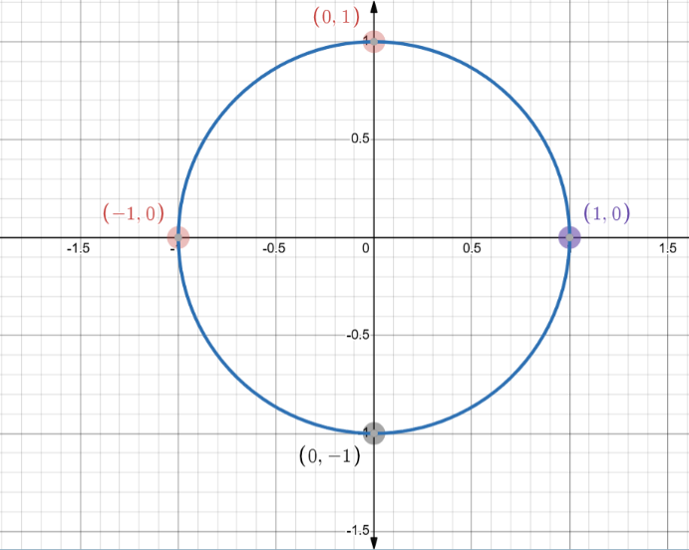
Definition:
A Circle with radius of ____ unit, on the ______________ Plane. This is called the Unit Circle.
The following function creates the unit circle:

$$\text{_________}+\text{__________}=\text{___________}$$

Example 1:
Determine the equation of a circle with centre at the origin and radius 4.

Determine the coordinates for points of the Unit Circle:

Example 2:
Determine the coordinates for all points on the Unit Circle that satisfy the coordinate given. Draw a diagram in each case.
- The x-coordinate is $\frac{\sqrt{2}}{2}$.

- The y-coordinate is $-\frac{1}{2}$ and the point is in quadrant III.

Coordinates of a Point on the Unit Circle Given an Angle

Key idea:

- The x-coordinate uses: _______
- The y-coordinate uses: _______

Exact coordinates can be determined by __________ ______________.

Example 3:
Determine the coordinates of the point on the unit circle that corresponds to the angle $θ=\frac{π}{6}$.

Multiples of $π$ on the unit circle

Definition:
Angles around the unit circle can be written as _________ ____ $π$.
Common angles include:
$\frac{π}{6}$ $\frac{π}{4}$ $\frac{π}{3}$ $\frac{π}{2}$ $π$ $\frac{3π}{2}$ $2π$

Example 4:
Determine the coordinates of the points on the unit circle for the angles $\frac{π}{3}$ and $\frac{5π}{3}$.

Create your own Example:
Choose a multiple of π between 0 and 2π and determine the coordinates of the corresponding point on the unit circle.
Angle chosen: __________
Coordinates: ____________________________

