

**Inclusion and Intervention Plan**

**(BLANK)**

|  |  |
| --- | --- |
| School Division:School:Student: **Birth Date:** | **School Division ID:**  **Gender:**  **Grade:**  **Ministry ID:** |

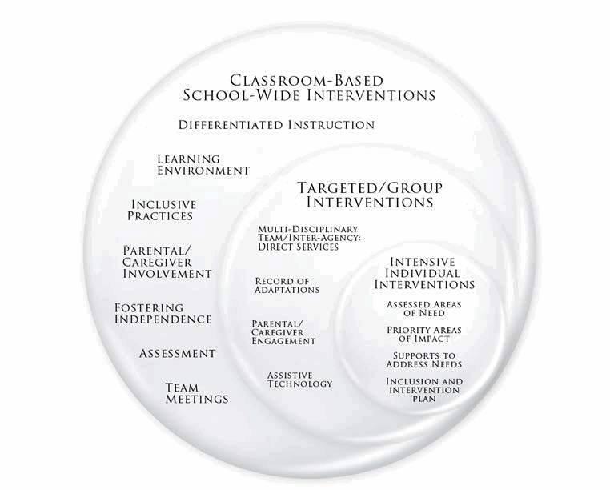

**IIP CONTEXT**: This IIP was created to support a fictional student with a Specific Learning Disorder who is in Grade Four. This initial IIP would be reviewed and adjusted as more information about the student’s strengths and needs becomes available through observation and assessment.

**DISCLAIMER:** This sample IIP is intended to serve as an example of how a team might complete an IIP for a student. All names, personal information and scenarios are fictional, constructed solely for the purpose of providing a sample IIP.

**ACKNOWLEDGEMENT:** The Ministry of Education would like to thank Prairie South School Division No. 210 for their input and collaboration in creating this sample IIP to support school teams when developing individualized plans for students.

**Who is the Student?**

|  |
| --- |
| **As a team, describe the student's strengths, interests, learning styles, needs and any additional information that is critical to optimizing success for this student.** |

**Current Student Assessment Information**

|  |
| --- |
| **All students have different learning capacities and learn at different rates. According to the team, _______________’s learning capacity is best described as:** |

**Assessment & Diagnostic Information**

|  |  |  |
| --- | --- | --- |
| **Diagnosis Obtained as a Result of Assessment or Name of Assessment** | **Professional/Role/Agency that Completed the Assessment** | **Year Assessment was Completed** |
|  |  |  |
|  |  |  |
|  |  |  |

**Relevant Medical Information**

|  |
| --- |
|  |

**Area of Development**

|  |  |  |  |  |
| --- | --- | --- | --- | --- |
|  |  |  |  |  |

|  |
| --- |
| **a. What measurable outcome do we want the student to achieve by June?** |

|  |
| --- |
| **b. How is the student doing on this outcome right now?** |

|  |
| --- |
| **c. Source of Outcome Assessment:** |

|  |
| --- |
| **d. Person(s) responsible for outcome assessment:** |

|  |  |  |
| --- | --- | --- |
| **Sources of Support** | | |
| **School Team**  **Frequently:**  **Occasionally:**  **Periodically:** | **School Division Team**  **Frequently:**  **Occasionally:**  **Periodically:** | **Outside Agencies**  **Frequently:**  **Occasionally:**  **Periodically:** |

|  |
| --- |
| e. Strategies (with whom, where, and when) to support the achievement of student outcome: |

**Area of Development**

|  |  |  |  |  |
| --- | --- | --- | --- | --- |
|  |  |  |  |  |

|  |
| --- |
| **a. What measurable outcome do we want the student to achieve by June?**  . |

|  |
| --- |
| **b. How is the student doing on this outcome right now?** |

|  |
| --- |
| **c. Source of Outcome Assessment:** |

|  |
| --- |
| **d. Person(s) responsible for outcome assessment:** |

|  |  |  |
| --- | --- | --- |
| **Sources of Support** | | |
| **School Team**  **Frequently:**  **Occasionally:**  **Periodically:** | **School Division Team**  **Frequently:**  **Occasionally:**  **Periodically:** | **Outside Agencies**  **Frequently:**  **Occasionally:**  **Periodically:** |

|  |
| --- |
| e. Strategies (with whom, where, and when) to support the achievement of student outcome: |

**Area of Development**

|  |  |  |  |  |
| --- | --- | --- | --- | --- |
|  |  |  |  |  |

|  |
| --- |
| **a. What measurable outcome do we want the student to achieve by June?** |

|  |
| --- |
| **b. How is the student doing on this outcome right now?** |

|  |
| --- |
| **c. Source of Outcome Assessment:** |

|  |
| --- |
| **d. Person(s) responsible for outcome assessment:** |

|  |  |  |
| --- | --- | --- |
| **Sources of Support** | | |
| **School Team**  **Frequently:**  **Occasionally**:  **Periodically:** | **School Division Team**  **Frequently:**  **Occasionally:**  **Periodically:** | **Outside Agencies**  **Frequently:**  **Occasionally:**  **Periodically:** |

|  |
| --- |
| e. Strategies (with whom, where, and when) to support the achievement of student outcome: |

**Transition Plans**

|  |
| --- |
| **Short-term Transition Plans:** |
| **Long-term Transition Plans:** |

**Additional Information**

|  |
| --- |
|  |

|  |
| --- |
| **Signatures of Team Members**    Parent/Guardian Date  Parent/Guardian Date  Student (if applicable) Date  Classroom Teacher Date    Student Support Services Teacher Date  Administrator / Principal Date    Other Date      Other Date    Other Date |